Katreena Scott, Ph.D. C. Psych.
Tim Kelly, MSW RSW.
Claire Crooks, Ph.D. C. Psych.
Karen Francis, Ph.D. C. Psych.
Caring Dads
Program Workbook
3
rd Edition
Caring Dads Service Agreement
Program Commitment
We commit to providing you with a program that is designed to help you think carefully about how you relate to your children. We will work with you to change parenting practices that are harmful and to develop skills to improve your relationship with your children.
We will provide you with open and honest assessments about your behavior and will make appropriate referrals and recommendations if needed.
We will treat you with respect.
We will be honest about your participation and progress.
Suggestions for changes and improvement of services and complaints or grievances may be expressed to your group co-facilitators. If necessary, you may then contact __________________________________________ who will forward your comments for discussion at working group meetings.
Confidentiality
Your identity and written and oral statements will be kept confidential with the following exceptions:
- If there are reasonable grounds to suspect child abuse, a report will be made to child protective services
- If you make threats or gestures of harm towards yourself or others, it will be reported to the appropriate persons and/or authorities • If disclosure is required by Court Order or subpoena
As part of our commitment to treat you with respect, we will, to the best of our ability, inform you if we feel the need to break confidentiality.
In addition, program co-facilitators will maintain open communication with your referral agents (i.e. child protective services and probation and parole).
Communication
If you share custody, the mother of your children and children that you regularly care for will be given general information about the Caring Dads program. She will also be provided with support and resources, if she chooses. This contact is in the best interests of your children, and we require that you do not interfere with this contact or use it against the mother of your children. In the case that the mother of your children contacts Caring Dads during your involvement with this program, we will share with her general information about the Caring Dads program (e.g. number of weeks, content of session). We will need your consent to share any information with her about your particular involvement in this group. The Caring Dads program does not provide letters of support to men, their lawyers or other professionals. Once you have begun the program, a letter will be sent to your referral agent indicating that you have enrolled in the program. Regular updates on your attendance will be provided, upon request, to your referral agent. Once you have completed the program, a final report will be sent to your referral agent.
If you become involved in regularly caring for additional children while you are in the program, you are asked to provide the name and contact information for the mother of these children to program co-facilitators.
The Caring Dads program requires you to sign Release of Information consent forms for communication between Caring Dads and your referral agent. If you share custody of your children, you will also be required to consent for release of the name and contact information of the mother of your children. If you are involved with other professionals, you may be asked to sign additional consent and release of information forms.
Advisory about Program Completion
Program completion does not guarantee that you will improve your parenting. Developing better parenting skills depends upon your own behavior and commitment. The final report made to your referral agent will reflect the judgments of your group facilitators about your participation and learning in group.
Limits of Involvement
You are expected to report to group co-facilitators any criminal behavior (e.g. assault, stalking, breach of restraining order, breach/violation of probation or custody and access agreements, failing to make child support payments), regardless of who the offence was against or whether the criminal justice system was involved. Co-facilitators will work with you to ensure behaviors are reported to the proper authorities.
You are expected to abstain from using alcohol and recreational drugs 24 hours prior to group meetings. Any man who arrives at group having used such substances will be asked to leave the meeting. You should inform your group co-facilitator if you are taking prescription drugs that alter your emotions or behavior (i.e. anti-depressant, anti-psychotic, sedatives). You may be asked to sign a release of information so that the purpose of this prescription can be discussed with your physician.
You are expected to wear appropriate clothing. You will be asked to obscure (e.g. by turning your shirt inside out) or remove any clothing viewed by group co-facilitators as racist, sexist or otherwise disrespectful.
You are not permitted to enter group premises with weapons of any kind. You are expected to be respectful of others in the group by maintaining others’ confidentiality and using respectful language.
Persistent or gross disregard of any of the above rules may be addressed in a number of ways. You may be asked to develop an agreement with your co-facilitators and/ or other authorities for more appropriate behavior (this is most often the first step). The program may impose additional conditions on your continued participation in group. Finally, you may be asked to leave the program.
Other Rules
Smoking is not permitted anywhere in the building. Smoking is permitted outside of the building at the front door. You will be allowed re-entrance by the group facilitator.
Cellular telephones and paging devices must be turned off during group. Personal telephone calls are permitted in cases of emergency.
Attendance and Participation
The fathering program runs one night a week for 17 weeks. You are expected to attend all sessions but are permitted to miss a maximum of two sessions for documented reasons (e.g. family emergencies, sickness). If you are going to miss a session (or if you have missed a session), you need to call _________________________________ to let your facilitators know. You will need to collect handouts and complete homework from missed sessions. If you miss more than two sessions, you will be discharged from the program. You may not miss consecutive sessions without permission from group cofacilitators.
Meetings start promptly at the scheduled time and run for two hours. In general, men who arrive late will not be admitted into the group.
Groups do not run on statutory holidays. In cases of unexpected inclement weather you should call ___________________________________ for information about whether or not the group is cancelled.
You are expected to participate actively in group discussions, to accept challenges, and to challenge others respectfully.
You are expected to complete all homework assignments. You will be considered to have completed the program only when all homework assignments are completed and have been checked by a group facilitator.
Caring Dads
Program Rules
1.
Keep confidentiality within the group. When discussing group activities,
focus only on your contribution.
2.
Maintain respectful behavior toward everyone in the meetings.
3
.
Use first names when speaking to other group members or when
making reference to women or children in your life.
4
.
Do not use alcohol or drugs in the 24 hours prior to your meeting.
5.
Active participation in group is required.
6.
Meetings begin sharply at the scheduled time.
7
.
Always bring your workbook.
8.
Stay focused on the meeting theme.
Appendix B:
Program Workbook
Name:________________ Date:________________

Session 2 Homework My Goals
Name one thing you can do to be a better father:
__________________________________________________________________
__________________________________________________________________
__________________________________________________________________
Name one thing you can do to treat your child’s mother better:
__________________________________________________________________
__________________________________________________________________
__________________________________________________________________
Examples:
- Pay attention to what my child needs
- Have a closer relationship with my child
- Know how to deal with my child’s problems
- Find out what makes my child happy or sad
- Get more involved in my child’s life
- Stop blaming my child’s mother for everything
- Take care of myself so I can be a better parent
Name:________________ Date:________________

Session 3
My goal:___________________________________________
How will I do this?
__________________________________________________________________
__________________________________________________________________
__________________________________________________________________
__________________________________________________________________
My goal:___________________________________________
How will I do this?
__________________________________________________________________
__________________________________________________________________
__________________________________________________________________
__________________________________________________________________

Session 3 Feelings Sheet
Love Dislike
Hopeful Hopeless
Happy Unhappy
Brave Scared or Nervous
Proud Mad or Angry
Excited Confused

Fathering Circles Past
What My Father Felt Like
This circle shows how you felt about your father.
Step 1: Write how you felt about your father in the circle. You can take some
feelings from the list on Page 4.
Step 2: Write the biggest and strongest feelings in big letters. Smaller
feelings can be written using smaller letters. You can also use smiley faces.
The left circle shows you what to do.
Put your feelings in the circle on the right.
When I was a child, I felt ____________ about my father.

Scared

Disappointed

Loved

Happy

Mad

Lonely

Confused
Fathering Circles Present

How I Think My Child Feels
Imagine how your child feels about you. Write those feelings down using words or smiley faces.

I think that my child feels ____________ about me.

Fathering Circles Ideal How I Want My Child To Feel About Me
How do you want your child to feel about you? Write those feelings down using words or smiley faces.

I want my child to feel ____________ about me.

Parenting Continuum
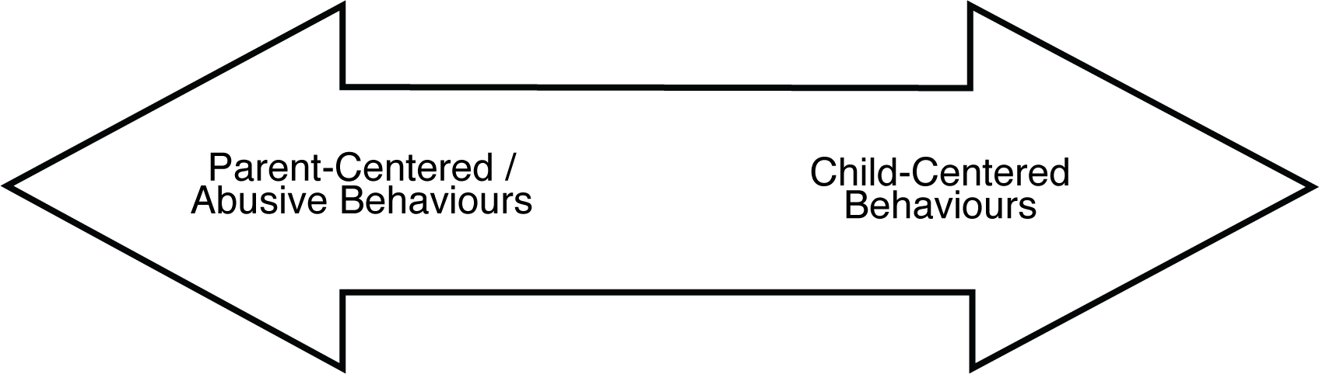

Loves child only when they are being good
Makes fun of or teases child
Doesn’t show love towards child
Doesn’t make time for child
Not sensitive to child’s needs
Scares or threatens child
Mean or disrespectful to the child’s mother
Is mean to the child when they do something wrong
Shows kindness to child’s
mother
Makes child feel special
Helps child stay safe
Talks to child about things they are care about

Has reasonable goals and expectations for child
Cares about what child has
to say
Is proud of their child
Respectful co-parenting

Nurturing Wheel
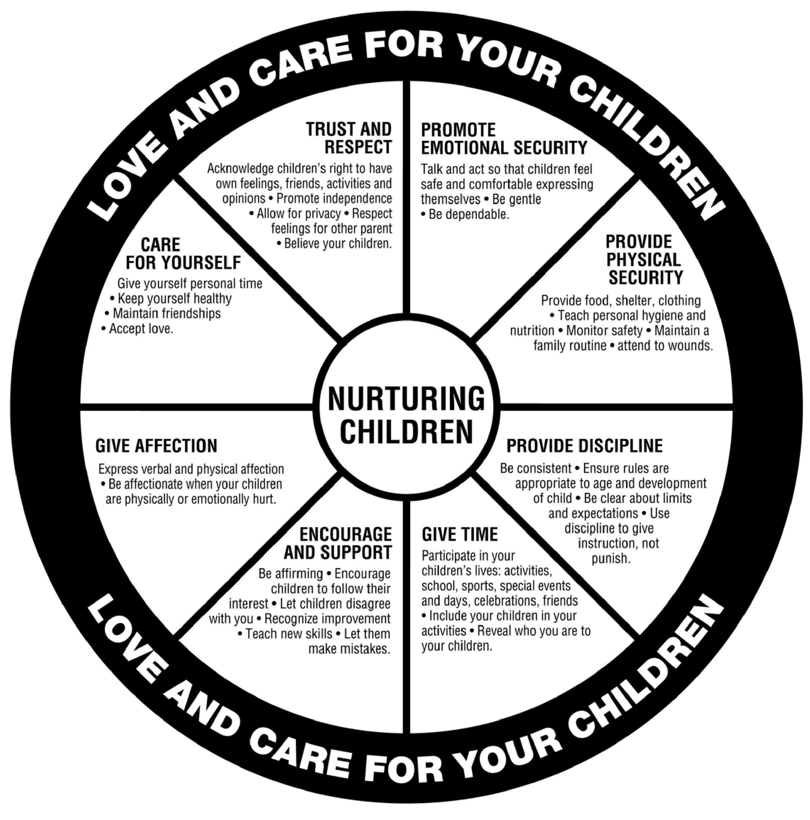

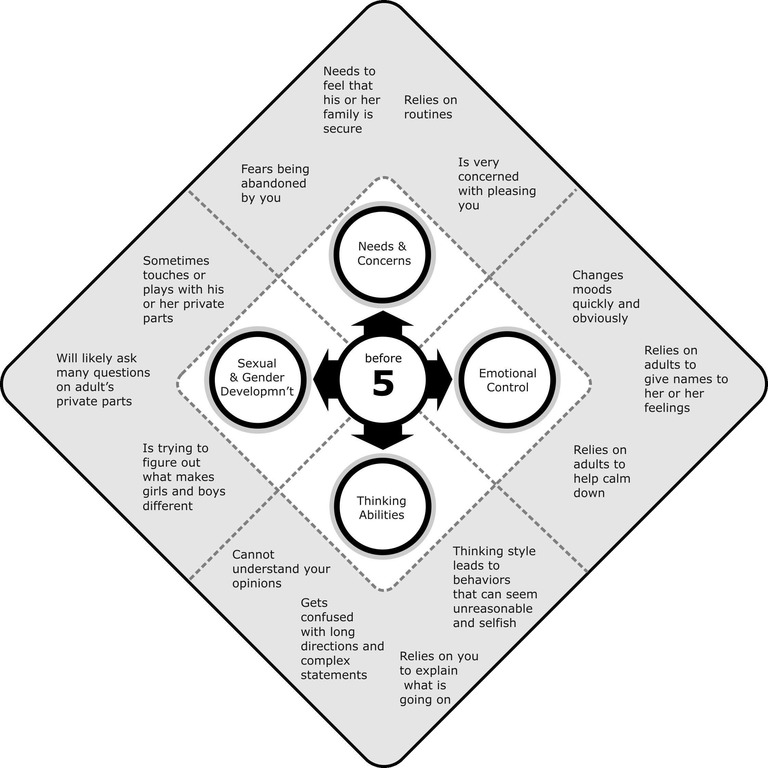

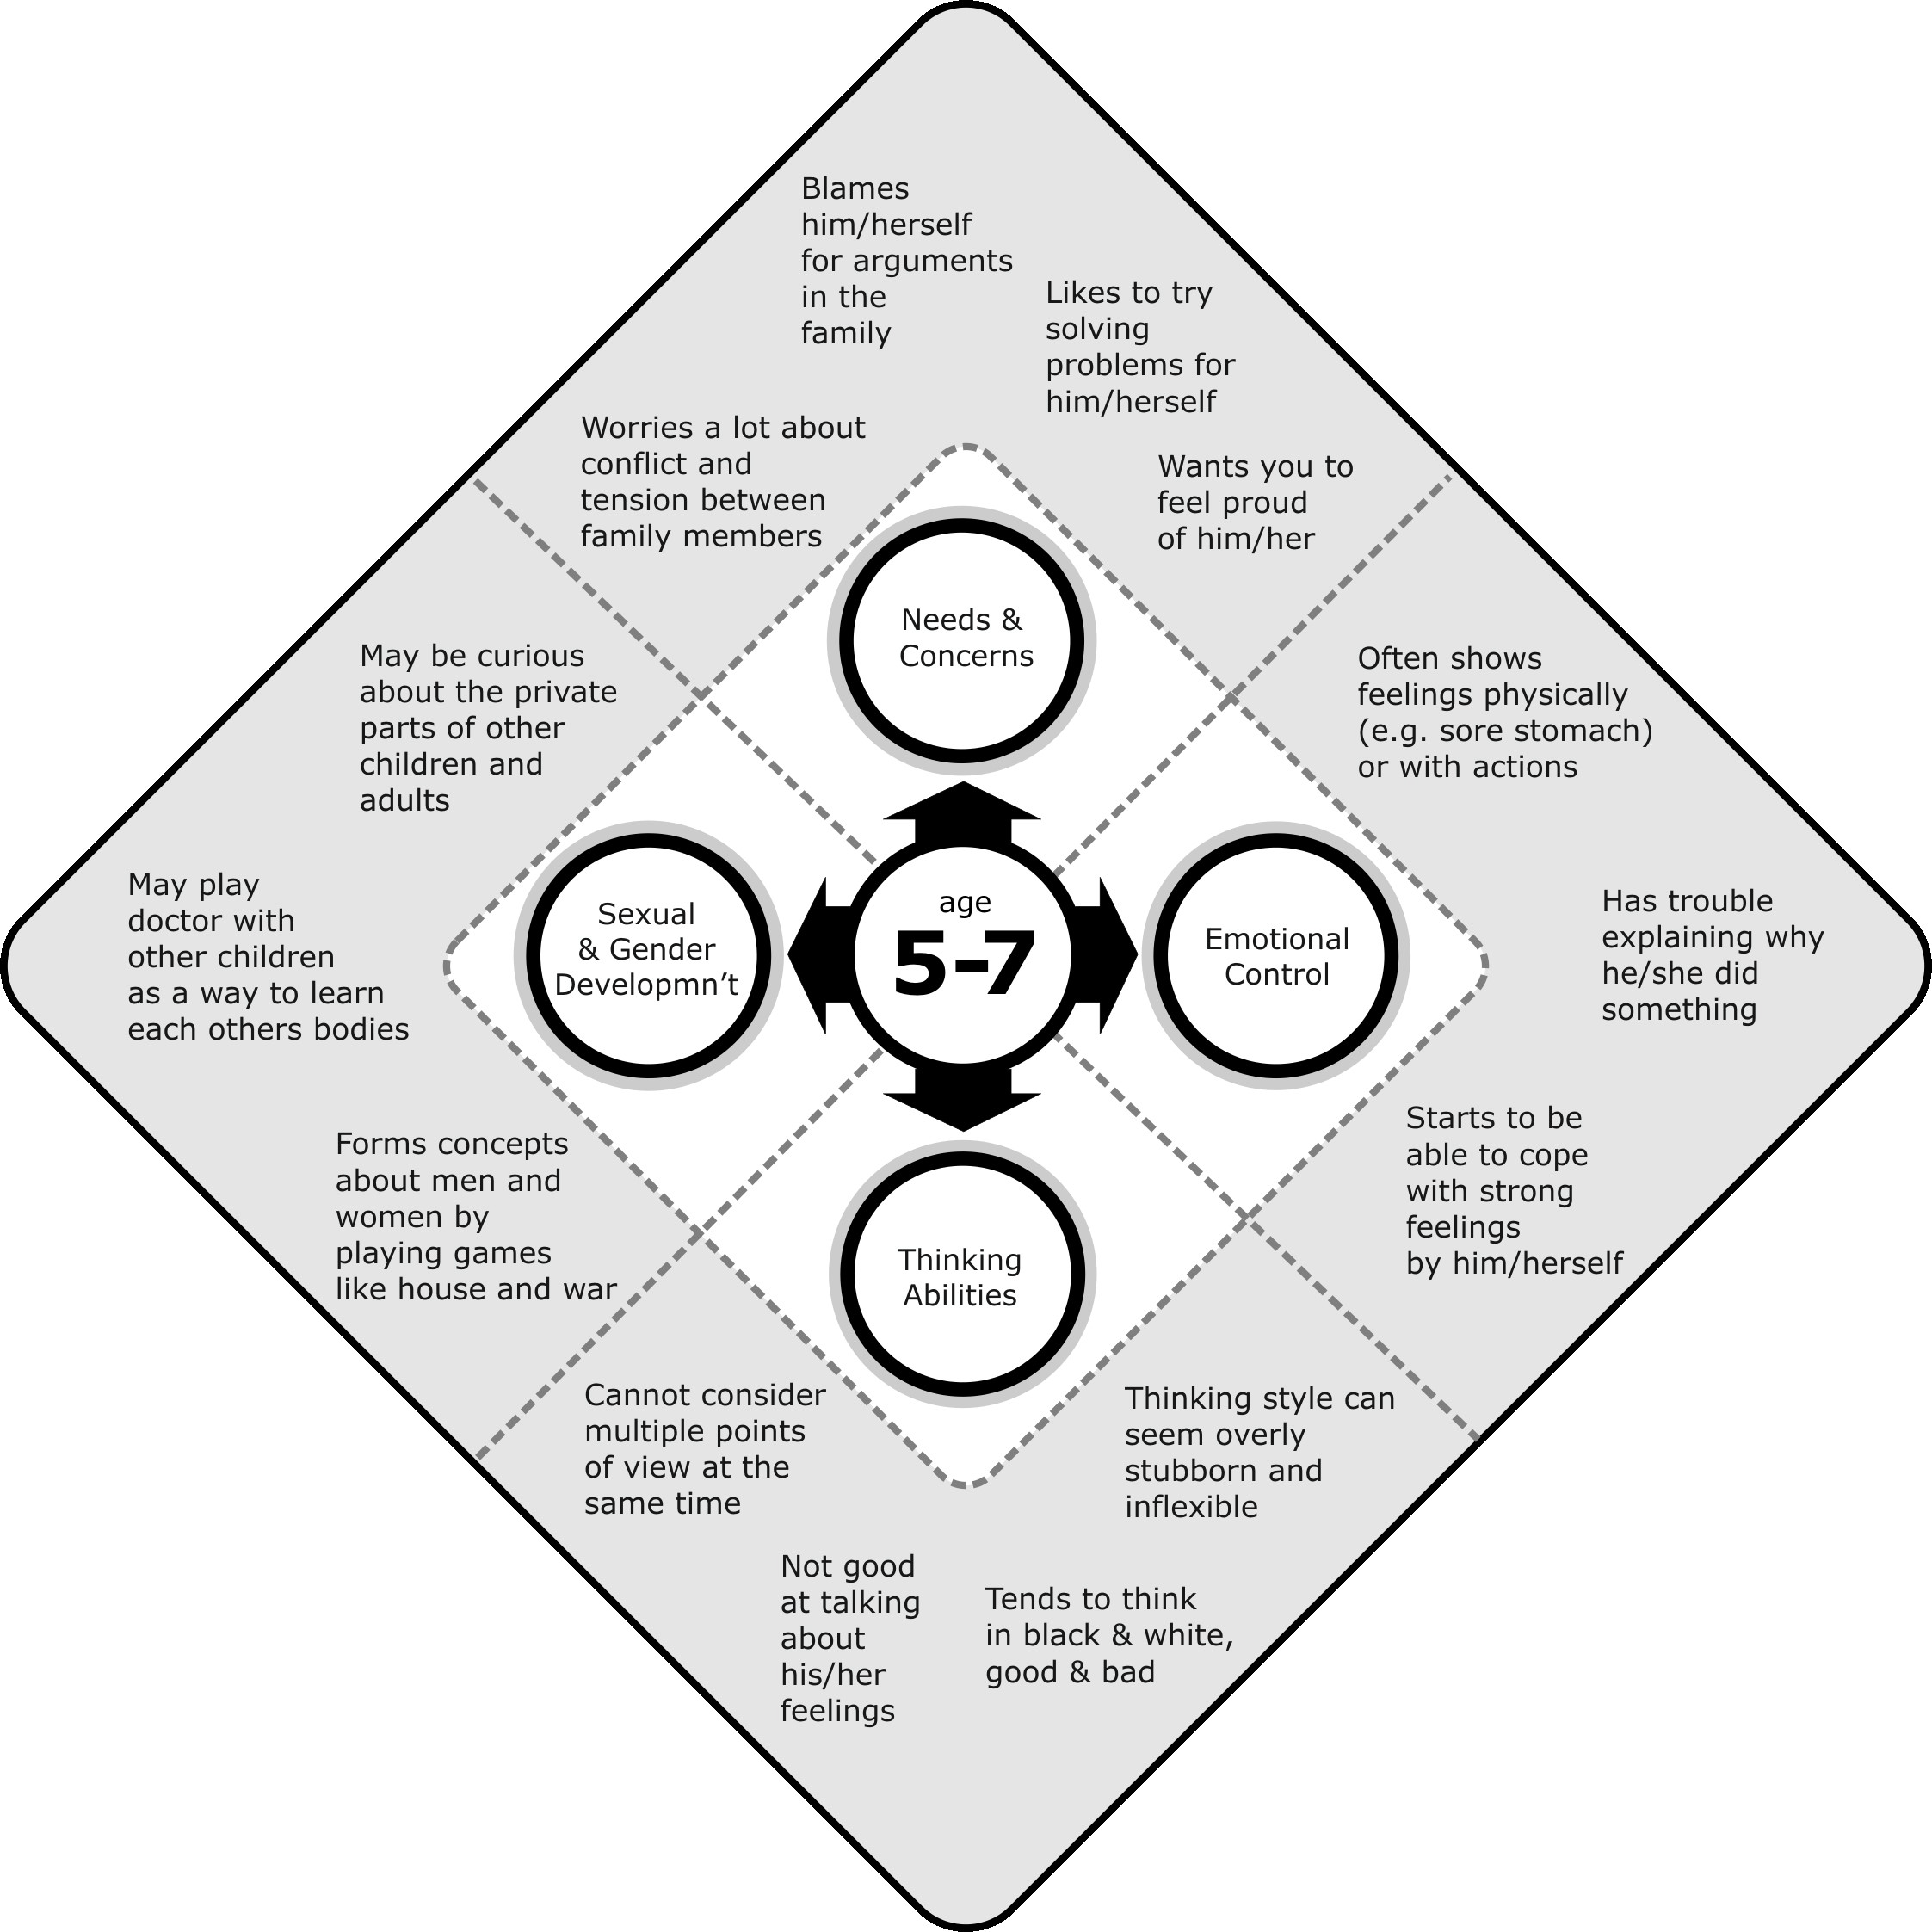

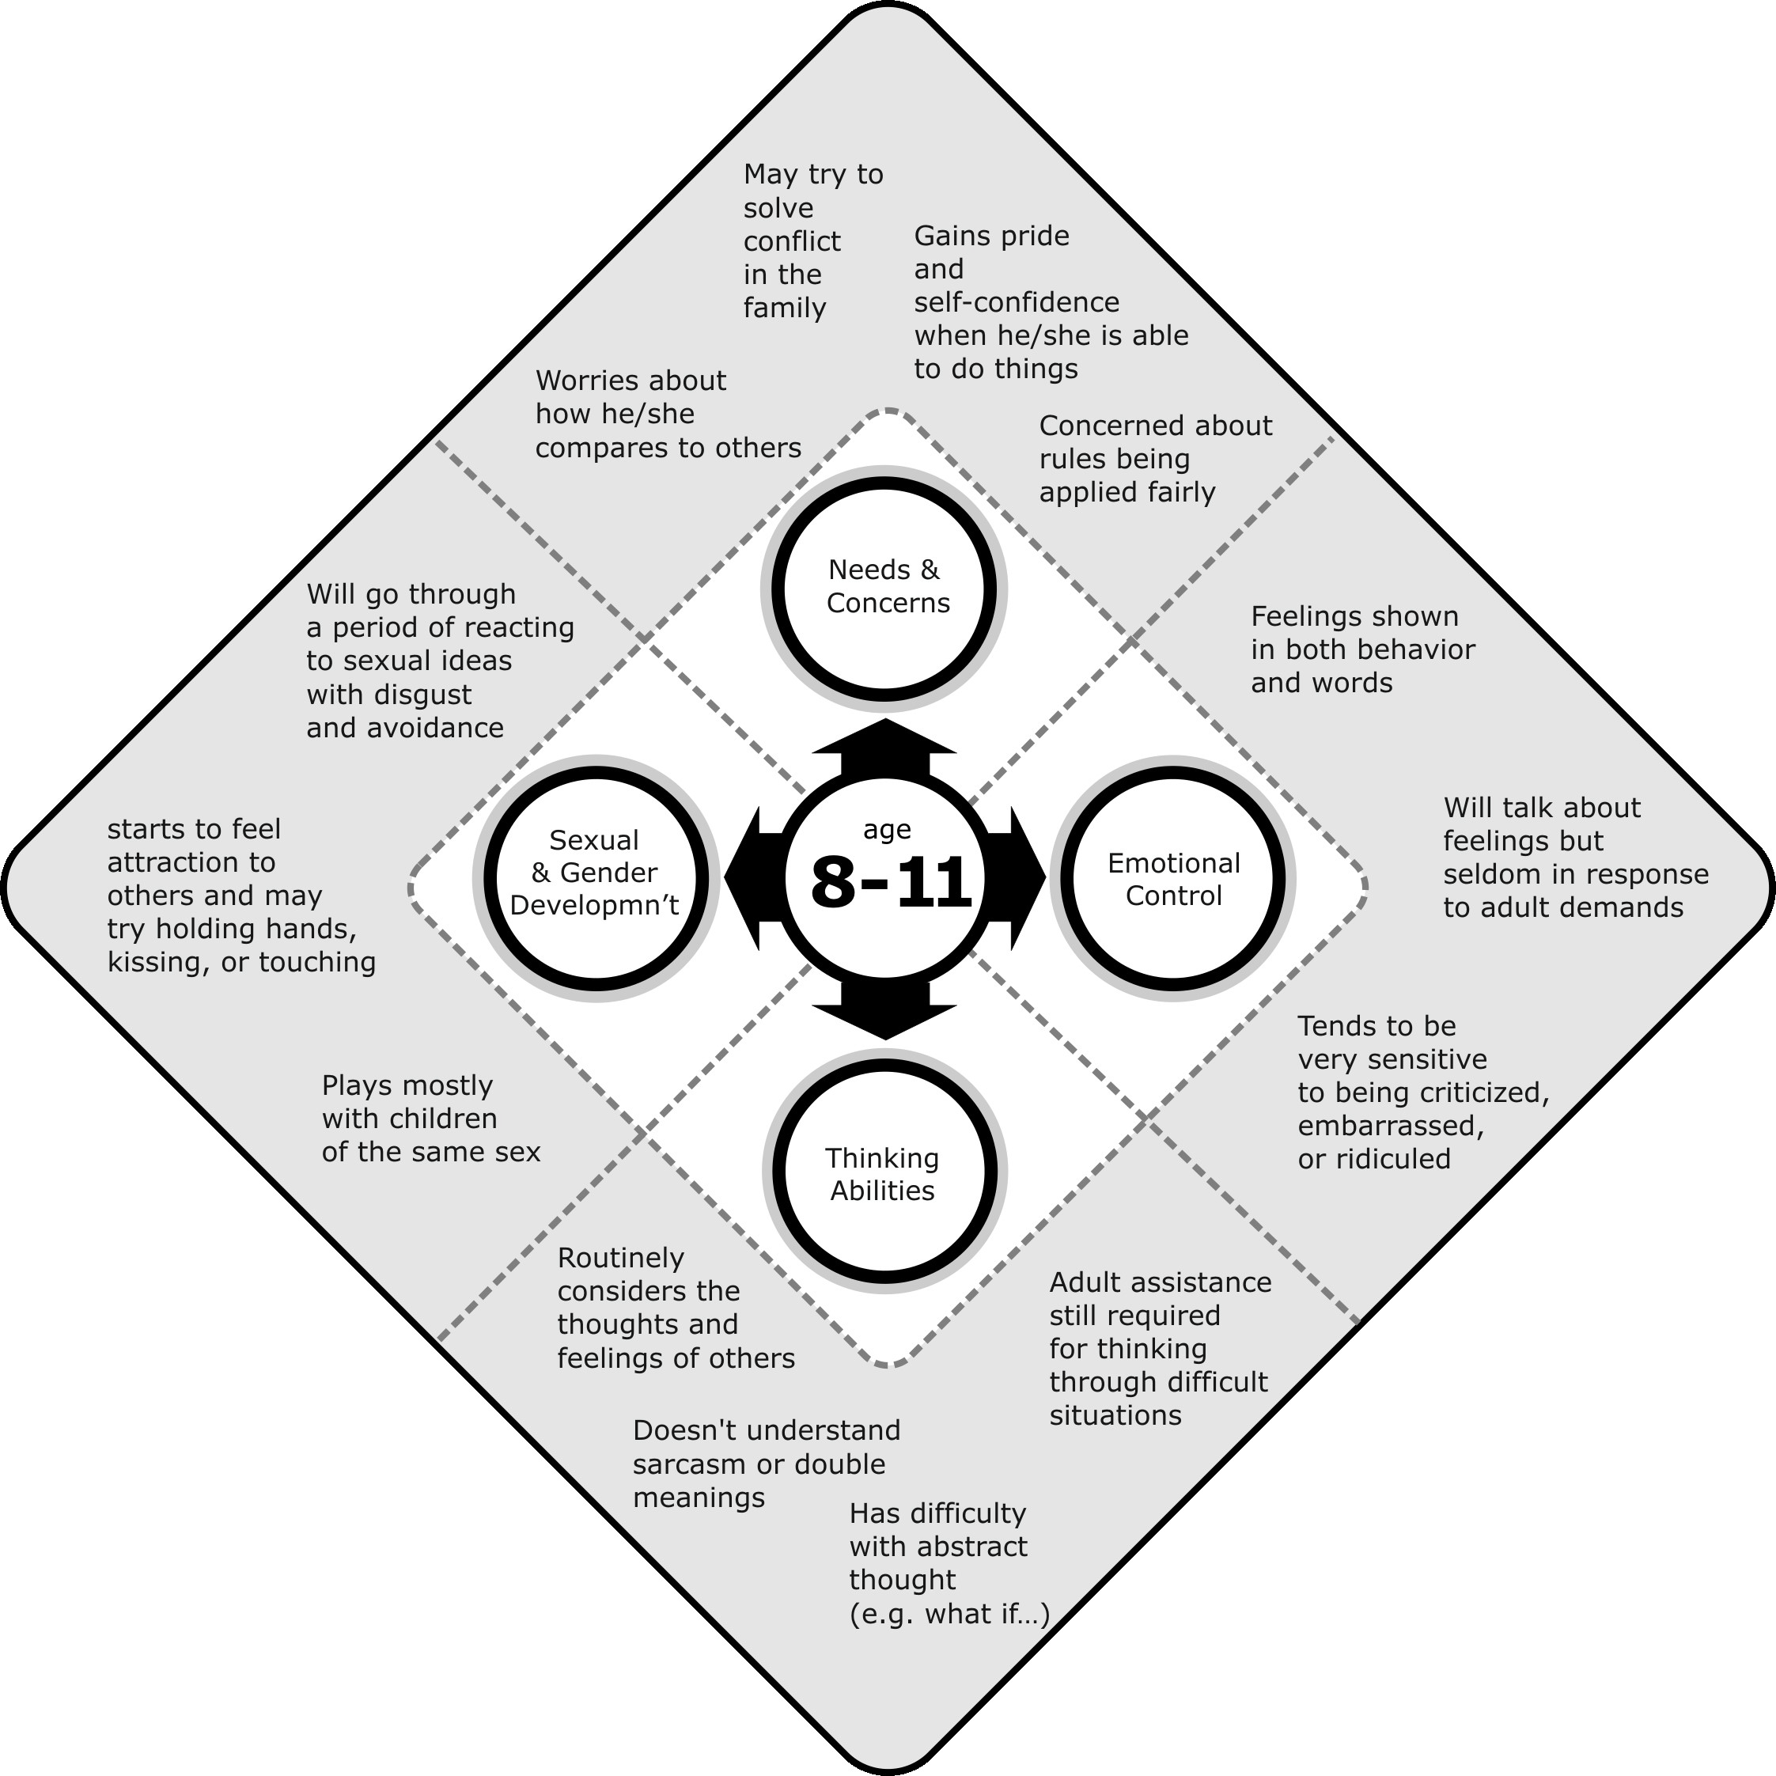

Session 4
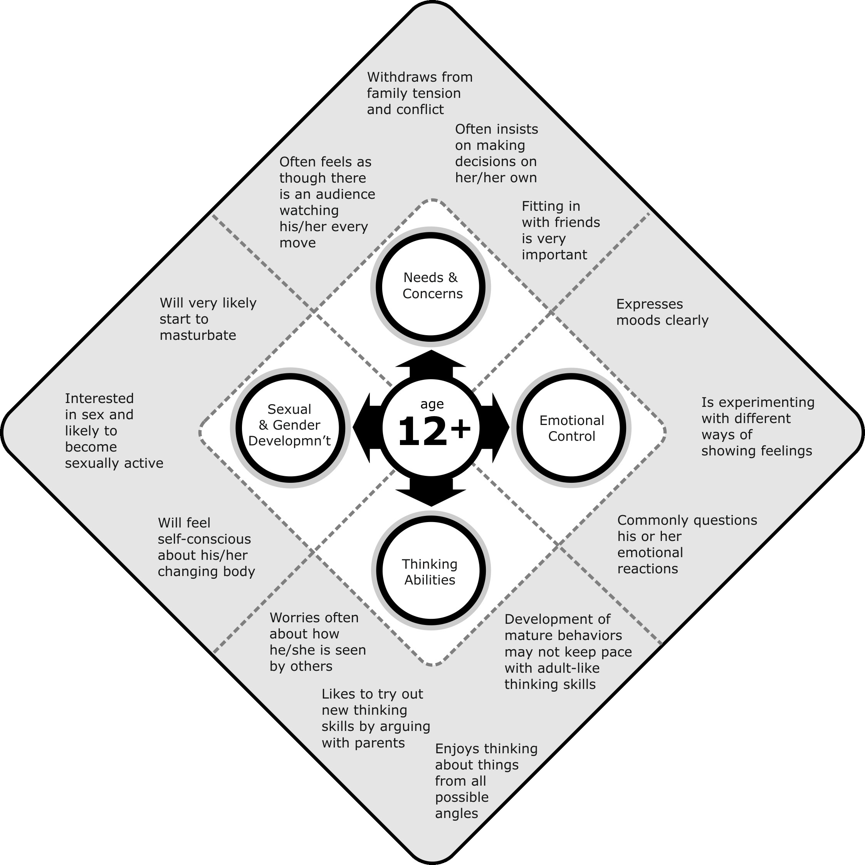
Name:________________ Date:________________
Session 4

Homework
- Love and attention
- Understanding
- Fair limits
- Listening
- Respectful coparenting
Ways that I can be a Child-Centered father...
__________________________________________________________________
__________________________________________________________________
__________________________________________________________________
__________________________________________________________________
__________________________________________________________________
__________________________________________________________________
__________________________________________________________________
__________________________________________________________________

Session 5 How Well Do I Know my Child? - Quiz
BABY TO 4 YEARS OLD:
1. What are your child’s favourite toys?
__________________________________________________________________ 2. What does your child like to learn about?
__________________________________________________________________ 3. What is something he/she really likes to do?
__________________________________________________________________ 4. What does your child like to do with you?
__________________________________________________________________ 5. What does your child like to do with his/her mother?
__________________________________________________________________ 6. How do you know if your child is upset?
__________________________________________________________________ 7. What makes your child most upset?
__________________________________________________________________ 8. What is your child afraid of?
__________________________________________________________________ 9. What makes your child happy?
__________________________________________________________________ SCHOOL AGE
1. What does your child like to play with?
__________________________________________________________________ 2. What does your child want to be when he/she grows up?
__________________________________________________________________ 3. What does your child want for his/her birthday?
__________________________________________________________________ 4. What does your child like to do with you?
__________________________________________________________________ 5. What does your child like to do with his/her mother?
__________________________________________________________________ 6. How do you know if your child is upset?
__________________________________________________________________ 7. What is your child afraid of?
__________________________________________________________________ 8. Has there been anything lately that disappointed your child?
__________________________________________________________________ 9. What is your child proud of?
__________________________________________________________________ TEENAGER
1. What class does your child like most in school?
__________________________________________________________________ 2. What is your child’s favourite music?
__________________________________________________________________ 3. Name your child’s friends. What do they do together?
__________________________________________________________________ 4. What does your child like to do with you?
__________________________________________________________________ 5. What does your child like to do with his/her mother?
__________________________________________________________________ 6. How do you know if your child is upset?
__________________________________________________________________ 7. Who does your child talk to when they are upset?
__________________________________________________________________ 8. What is your child afraid of?
__________________________________________________________________ 9. What does your child worry about?
__________________________________________________________________ 10. Has there been anything lately that disappointed your child?
__________________________________________________________________ 11. What is your child proud of?
__________________________________________________________________

Session 5 Some Things You Might Find Hard To Do
Part 1
Here are ways to build your relationship with your child. Some of them may be hard for you.
I might find it hard to:
Tell my child I love them |  | Yes | No
Give full attention when my child wants to talk |  | Yes | No
Ask my child about their feelings |  | Yes | No
Help my child with homework |  | Yes | No
Talk about my child’s feelings without arguing |  | Yes | No
Play a game that my child picks |  | Yes | No
Spend a long time alone with my child |  | Yes | No
Teach my child new things |  | Yes | No
Remember my child’s schedule |  | Yes | No
Tell my child they did a good job |  | Yes | No
Say sorry when I’m wrong |  | Yes | No
Support my child’s mother without fighting |  | Yes | No
Support my child’s relationship with their mother |  | Yes | No
Are there other things you find hard?
__________________________________________________________________
__________________________________________________________________
__________________________________________________________________ Part 2
List two things that make it hard to build a relationship with your child. Then talk about what you can do to get past these things.
1. _________________________________________________________________ __________________________________________________________________ What can I do instead?
- _________________________________________________________________
- _________________________________________________________________
- _________________________________________________________________
2. _________________________________________________________________ _________________________________________________________________ What can I do instead?
- _________________________________________________________________
- _________________________________________________________________
- _________________________________________________________________Name:________________ Date:________________

Session 5 Homework Weekly Fathering Log
This week, things I felt good about as a father were:
_________________________________________________________________
_________________________________________________________________
_________________________________________________________________
_________________________________________________________________
This week, I have been child-centered in my fathering by:
_________________________________________________________________
_________________________________________________________________
_________________________________________________________________
_________________________________________________________________
This week, things I struggled with as a father were:
_________________________________________________________________
_________________________________________________________________
_________________________________________________________________
_________________________________________________________________
How did you feel about your parenting this week?

Session 6
Tips for Being a Good Listener
- Make time for your children
- Pay attention
- Don’t try to fix the problem
- Ask questions
- Talk about and accept what your child is feeling
- Get to know how your child likes to talk
Name:________________ Date:________________

Session 6 Homework Weekly Fathering Log
This week, things I felt good about as a father were:
_________________________________________________________________
_________________________________________________________________
_________________________________________________________________
_________________________________________________________________
This week, I have been child-centered in my fathering by:
_________________________________________________________________
_________________________________________________________________
_________________________________________________________________
_________________________________________________________________
This week, things I struggled with as a father were:
_________________________________________________________________
_________________________________________________________________
_________________________________________________________________
_________________________________________________________________
How did you feel about your parenting this week?

Name:________________ Date:________________

Session 6 Homework Listening to, Praising, and Playing with my Children
This week, I listened to my child by...
_________________________________________________________________
_________________________________________________________________
_________________________________________________________________
This week, I praised my child by saying...
_________________________________________________________________
_________________________________________________________________
_________________________________________________________________
This week, I played with my child by...
_________________________________________________________________
_________________________________________________________________
_________________________________________________________________
Definitions:
Praise To say good things about your child.
Example: “Great work on your math test, son!”

Session 7
What Kind of Example Do I Set?
How would you rate yourself on the kind of example you set in treating your child’s mother?

1 2 3 4 5 6 7 8 9 10
I set a horrible I set an excellent
example example

I never respect I listen to my my child’s mother child’s mother
I am rude or mean I always support to my child’s mother my child’s mother Name:________________ Date:________________

Session 7 Homework Being a Good Model for My Children
Write down three ways you set a good example for your children in how to treat their mother or another important person in your children’s lives.
1. ________________________________________________________________
__________________________________________________________________
2.________________________________________________________________
__________________________________________________________________
3. ________________________________________________________________
__________________________________________________________________ Name:________________ Date:________________

Session 7 Homework Weekly Fathering Log
This week, things I felt good about as a father were:
_________________________________________________________________
_________________________________________________________________
_________________________________________________________________
_________________________________________________________________
This week, I have been child-centered in my fathering by:
_________________________________________________________________
_________________________________________________________________
_________________________________________________________________
_________________________________________________________________
This week, things I struggled with as a father were:
_________________________________________________________________
_________________________________________________________________
_________________________________________________________________
_________________________________________________________________
How did you feel about your parenting this week?

Session 8 Worksheet Thoughts, Feelings, and Actions Triangle
Feelings
Actions Thoughts

Session 8 Worksheet Thoughts and Beliefs to Watch Out For
- If my child respected me, they would listen.
- A child who does not listen is disrespectful.
- A child should not disagree with their father.
- Children who don’t listen or argue with their father are disrespectful and should be punished.
- My child is... stubborn, stupid, spoiled, etc.
- If my child really cared about my feelings, they would...
- My child should know better, they are doing this to annoy me.
- My child is acting just like my... mother, father, brother, or other family member.
- If I don’t get control of my child, they are going to turn into a... deadbeat, criminal, drug addict, etc.
- I shouldn’t have to deal with this right now.
- If my child’s mother would just... then this wouldn’t happen.

Session 8 Homework
Think about two times you got mad or upset with your child this week. What happened and what were you thinking?
Talk about the first time you got mad or upset with your child.
__________________________________________________________________
__________________________________________________________________
__________________________________________________________________
__________________________________________________________________ What were you saying to yourself?
__________________________________________________________________
__________________________________________________________________
__________________________________________________________________
__________________________________________________________________ Talk about the second time you got mad or upset with your child.
__________________________________________________________________
__________________________________________________________________
__________________________________________________________________
__________________________________________________________________ What were you saying to yourself?
__________________________________________________________________
__________________________________________________________________
__________________________________________________________________
__________________________________________________________________

Session 8 Homework Weekly Fathering Log
This week, things I felt good about as a father were:
_________________________________________________________________
_________________________________________________________________
_________________________________________________________________
_________________________________________________________________
This week, I have been child-centered in my fathering by:
_________________________________________________________________
_________________________________________________________________
_________________________________________________________________
_________________________________________________________________
This week, things I struggled with as a father were:
_________________________________________________________________
_________________________________________________________________
_________________________________________________________________
_________________________________________________________________
How did you feel about your parenting this week?

Session 9 Homework Weekly Fathering Log
This week, things I felt good about as a father were:
_________________________________________________________________
_________________________________________________________________
_________________________________________________________________
_________________________________________________________________
This week, I have been child-centered in my fathering by:
_________________________________________________________________
_________________________________________________________________
_________________________________________________________________
_________________________________________________________________
This week, things I struggled with as a father were:
_________________________________________________________________
_________________________________________________________________
_________________________________________________________________
_________________________________________________________________
How did you feel about your parenting this week?

Session 9 Not Valuing Children Wheel
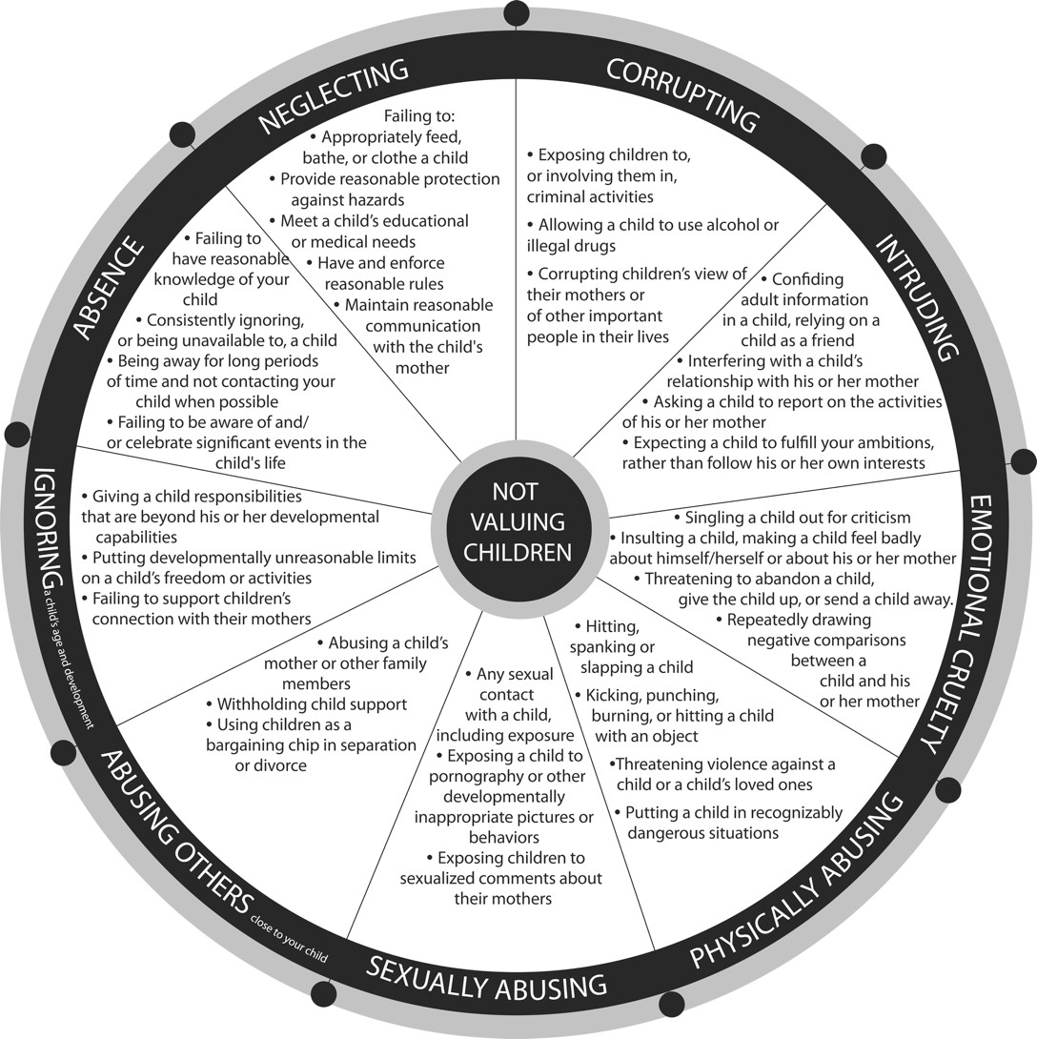
Name:________________ Date:________________

Session 9 Homework
Think about two things you do that are parent-centered. Write these down as goals for you to change. If you argue a lot with your children’s mother, write down one goal from this relationship.
Two ways I think I can change:
1._________________________________________________________________
__________________________________________________________________
2._________________________________________________________________
__________________________________________________________________
What do I need to change?
__________________________________________________________________
__________________________________________________________________
__________________________________________________________________
To change this I will:
__________________________________________________________________
__________________________________________________________________
__________________________________________________________________ Name:________________ Date:________________
Session 11 Homework

Problem-Solving for Parents
What made you upset?
__________________________________________________________________
__________________________________________________________________ What were you trying to do when you got upset?
__________________________________________________________________
__________________________________________________________________
Was this parent-centered or child-centered? __________________________
Feelings: ________________________
________________________
Actions: Thoughts:
_______________________ ________________________
_______________________ ________________________ How do you think your child felt?
__________________________________________________________________
__________________________________________________________________ What could you have done differently?
__________________________________________________________________
__________________________________________________________________
Session 12

Myths: How Children are Affected by Parental Conflict
 |  | MYTH |  |  | My child doesn’t even know what’s going on when we’re fighting.
 |  | MYTH |  |  | Fighting between parents has no real effect on children – they are not involved.
MYTH |  |  |  | My child may be upset for a while, but they will get over it soon enough.
 | MYTH |  |  |  | My children know that they shouldn’t hit people. I don’t hit people very often. Hitting only sometimes won’t change that.
 | MYTH |  |  |  | My children know that our fights are not their fault.
 | MYTH |  |  |  | You can be a good father and a “bad” husband.
Name:________________ Date:________________
Session 12 Homework

Problem-Solving for Parents
What made you upset?
__________________________________________________________________
__________________________________________________________________ What were you trying to do when you got upset?
__________________________________________________________________
__________________________________________________________________
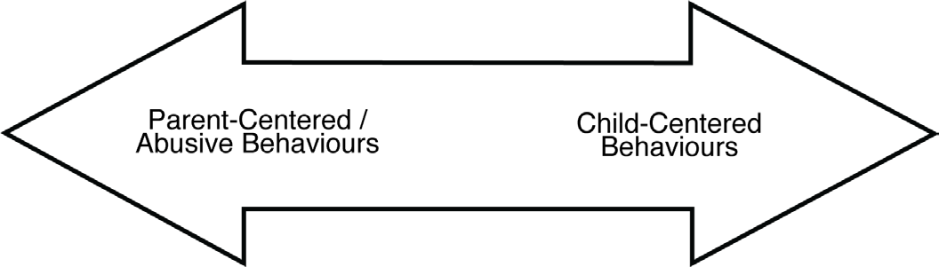
Was this parent-centered or child-centered? __________________________
Feelings: ________________________
________________________
Actions: Thoughts:
_______________________ ________________________
_______________________ ________________________ How do you think your child felt?
__________________________________________________________________
__________________________________________________________________ What could you have done differently?
__________________________________________________________________
__________________________________________________________________
Session 13 Worksheet

What Children Learn from Abusive and Controlling Fathering

- Being exposed to abuse of others close to them has long term effects on chil- dren. Children who have been exposed to domestic violence might learn to hit someone if they disagree with him/her.
- Boys who have lived with domestic violence while growing up learn that hitting is a good way to make someone stop doing what they don’t like. Girls learn that violence is something that they can expect in relationships.
- Children learn that other people are in control – especially bigger and stronger people. They don’t learn that they can make decisions by them- selves.
- Children might think it’s normal to hit people they care about.
- Children learn that it’s okay to hit people if they are feeling stressed or upset.
- Children learn that it’s okay for people to hit them if they do something wrong.
- Children learn to deal with authority figures like teachers by arguing or hitting.
- Children learn not to get caught.
- Children learn to stay away from the person that hit them. They learn that this person is not safe and might not help them when they need it.
Name:________________ Date:________________
Session 13 Homework

Problem-Solving for Parents
What made you upset?
__________________________________________________________________
__________________________________________________________________ What were you trying to do when you got upset?
__________________________________________________________________
__________________________________________________________________
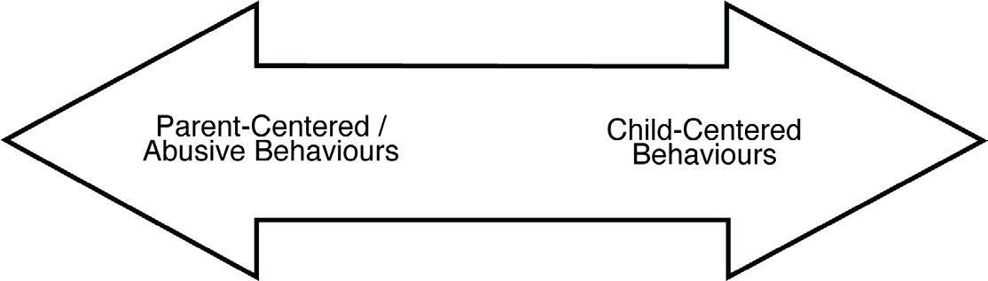
Was this parent-centered or child-centered? __________________________
Feelings: ________________________
________________________
Actions: Thoughts:
_______________________ ________________________
_______________________ ________________________ How do you think your child felt?
__________________________________________________________________
__________________________________________________________________ What could you have done differently?
__________________________________________________________________
__________________________________________________________________

Session 15 Talking to Children About Violence

Benefits of Talking to Kids About Violence:
- Children learn that violence isn’t their fault.
- Children learn that violence can’t be used to solve problems.
- It helps children feel cared for and understood.
- Children learn that it’s okay to talk about feelings.
- Children learn from you to take responsibility for their actions.

What Children Need to Hear You Say:
- It’s not your fault.
- I will listen to you.
- I am sorry that you saw, heard, or experienced that. What I did was not okay.
- I am sorry that something I did made you feel worried, hurt, or unsafe.
- There is nothing you could have done to prevent it.
- You can tell me how you feel.
- I care about how you feel.
- We can talk about how to make you feel safe.
- You do not deserve to have this in your family.
- I should not have done what I did.
- It must have been scary for you.
Name:________________ Date:________________

Session 15 Homework
List two problems that you are having with your children at this time.
- _________________________________________________________________
_________________________________________________________________
_________________________________________________________________
- ________________________________________________________________
_________________________________________________________________
_________________________________________________________________
How can I deal with these problems in a better way? How can I be more child-centered?
__________________________________________________________________
__________________________________________________________________
__________________________________________________________________
__________________________________________________________________
__________________________________________________________________
__________________________________________________________________

Session 16 Alternative Methods of Child Management
- Am I being reasonable? Can I do this differently?
- Can I change something so we don’t always fight about the same thing?
- Can I praise my child for doing good things?
- Is this a lesson for my children to learn? Can they learn this lesson from someone else?
- What’s really going on with my children? Can I do something about that?
Name:________________ Date:________________
Session 16 Homework How Have I Done?
Look at the goals you set for yourself on pages 2 and 3. How have you done?
What else did you learn?
1.________________________________________________________________
__________________________________________________________________
__________________________________________________________________
- __________________________________________________________________________________________________________________________________
__________________________________________________________________
- ________________________________________________________________
__________________________________________________________________
__________________________________________________________________

